ANSHUMAN — Comprehensive Design & Development Guide
AI-Based LPI Waveform Generation • SDR-Ready • End-to-End Blueprint
Table of Contents (Right-click → Update Field in Word)
1. Mission objectives, scope & deliverables
2. Requirements (functional & non-functional)
3. Threat model for LPI (what the adversary can do)
4. System architecture (Diagram B1)
5. Technology choices & “why not X” rationale
6. TX & RX signal pipelines (Diagram B3)
7. AI/ML design (G, Dec, D, Classifier), losses, curriculum (Diagram B2)
8. Security & keying plan
9. SDR integration (file formats, flowgraphs, calibration)
10. Test & validation plan (BER, AUROC, PSD gap; OTA steps)
11. Risk register & mitigations
12. Roadmap (Phase‑0 → Phase‑3)
13. BOM, software stack, field SOPs
14. Troubleshooting & FAQ
15. Glossary
16. Code mapping and parameter appendix

1) Mission objectives, scope & deliverables
- Transmit hidden information within noise-like I/Q waveforms (Low Probability of Intercept, LPI).
- Maintain reliable recovery at friendly receiver with low BER using FEC.
- Defend against classical detectors (energy, cyclostationary) and AI detectors (CNN on spectrograms).
- Integrate with SDRs (BladeRF/USRP) for lab and OTA trials.
- Deliver modular codebase, documentation, KPIs, and flowgraphs for field use.

2) Requirements (functional & non-functional)
Functional Requirements:
- Embed RS-coded bits in noise-like I/Q frames.
- Receiver reconstructs bits with BER ≤ 1% at SNR ≥ 15 dB (tunable).
- Export float32 interleaved I/Q .bin files for SDR playback/transmit.
- No obvious preambles or signatures that enable easy detection.
Non-Functional Requirements:
- Stealth: detector AUROC ≤ 0.6 vs baseline CNN at target SNRs.
- Robustness: tolerate AWGN + CFO ±200 Hz, ±50 ppm clock offsets (lab).
- Reproducibility: deterministic seeds; configuration files for all hyperparameters.
- Usability: simple CLI, SOP checklists, clear logs and metrics.

3) Threat model for LPI (what the adversary can do)
- Wideband energy detection, spectral kurtosis, and cyclostationary analysis.
- Supervised CNN-based spectrogram detectors trained on common modulations.
- Offline analysis of captured I/Q; adaptive thresholds and multi-sensor fusion.
- Active measures: jamming, probing, replay; channel state estimation attempts.

4) System architecture (Diagram B1)
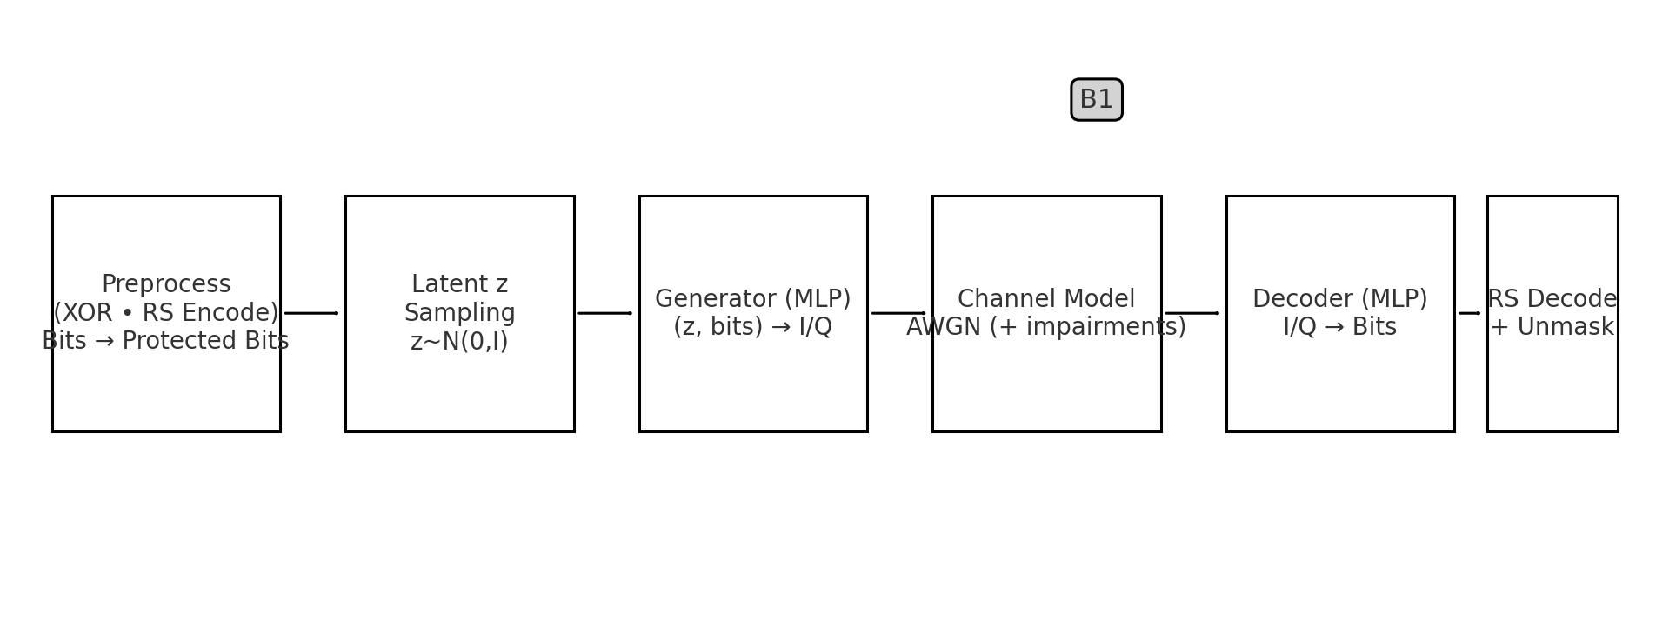
- Preprocess: XOR mask (demo) + Reed–Solomon (RS) FEC.
- Latent z: randomness to avoid repetitive structures; essential for stealth.
- Generator: conditional MLP maps (z, bits) → tanh-bounded I/Q.
- Channel: AWGN in baseline; extend with fading, CFO, timing offsets.
- Decoder: neural demapper recovers RS bitstream; RS decode + unmask → plaintext.
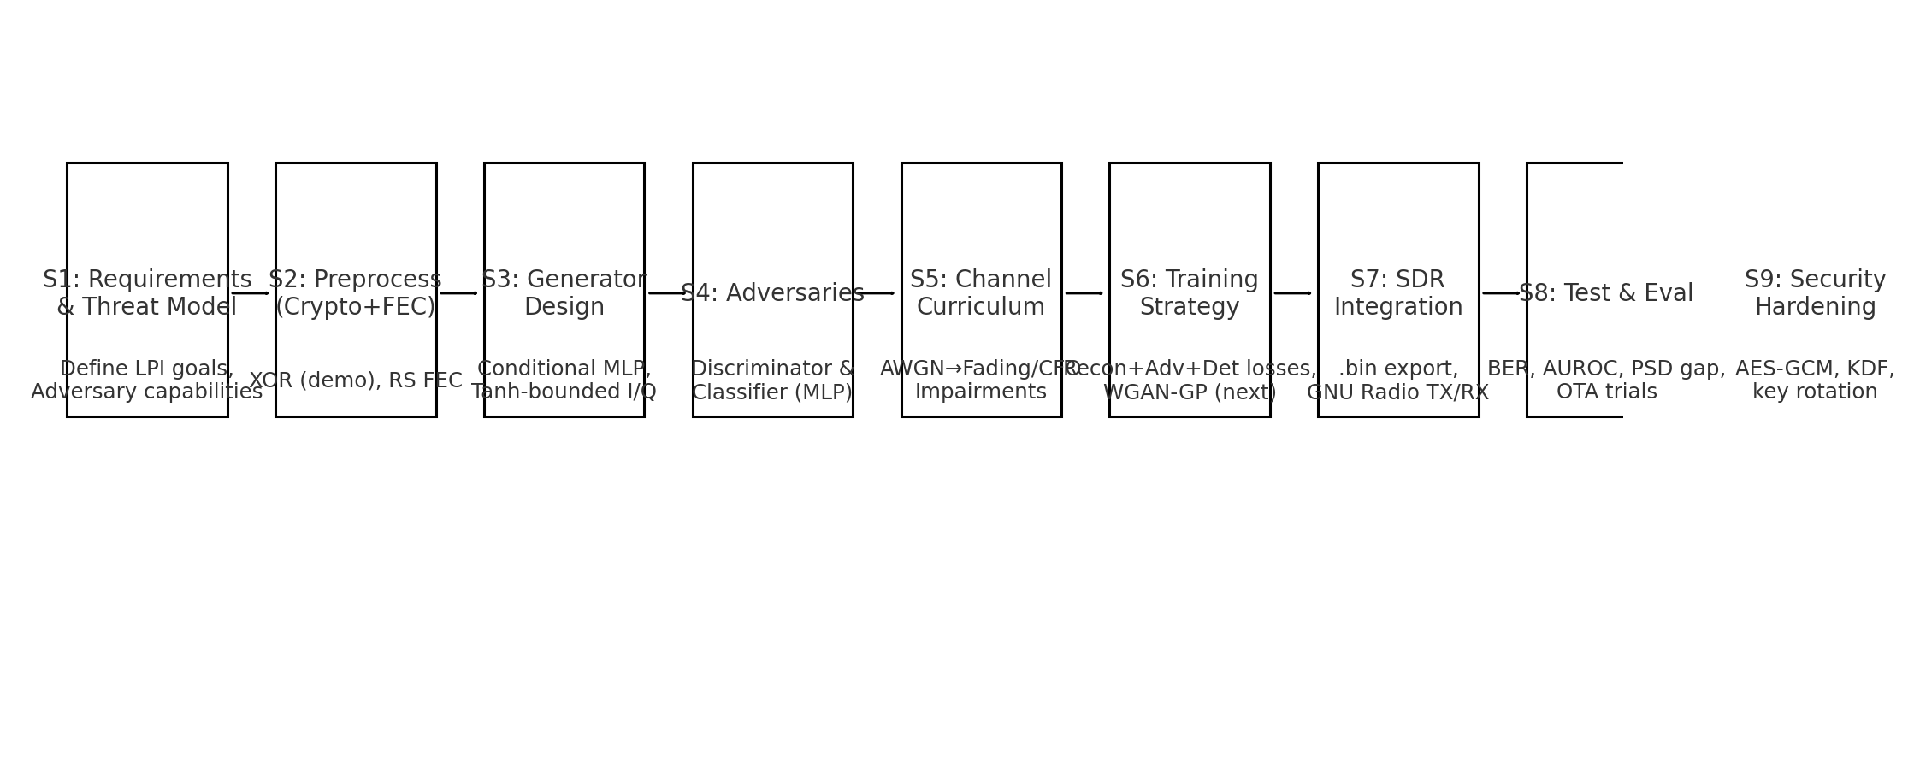
Scope/Implementation flow with AI/ML emphasis (S1–S9).

5) Technology choices & “why not X” rationale
- Chosen: PyTorch for G/Dec/D/C; numpy for bit ops; reedsolo for RS; matplotlib for diagrams; GNU Radio for SDR.
- Chosen: .bin float32 I/Q as interchange format (simple, fast, device-agnostic).
- Not now: OFDM and standard modems—introduce cyclostationary signatures; easier to detect.
- Not now: LDPC—higher coding gain but greater complexity; RS suffices for baseline.
- Not now: Full AES-GCM integration—kept out to reduce scope creep; earmarked for Phase‑2.
- Not now: CNN adversaries—start with MLPs for rapid iteration; add CNNs in Phase‑2.

6) TX & RX signal pipelines (Diagram B3)
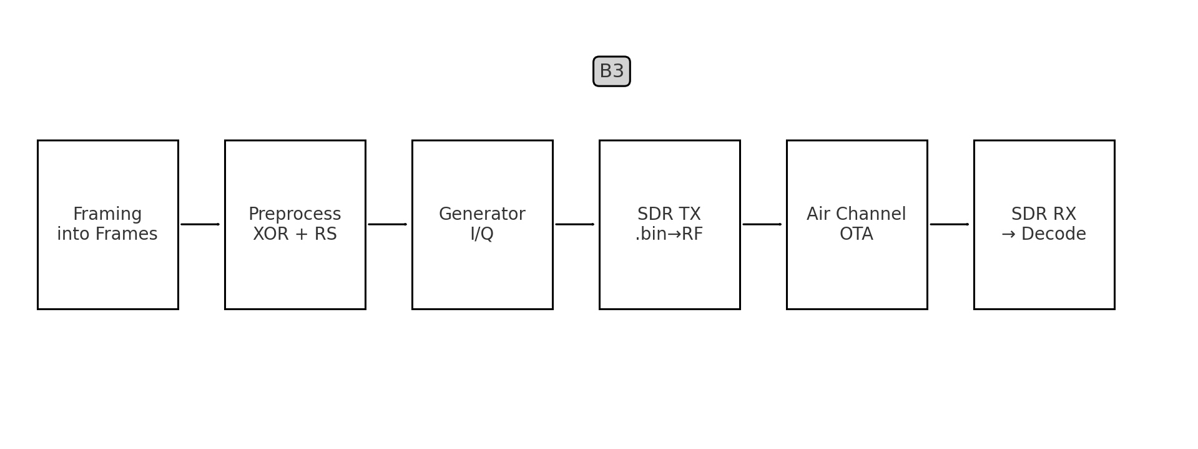
- TX: Plaintext → bitpack → XOR mask → RS encode → z sample → Generator → normalize/interleave → .bin export → GNU Radio TX.
- RX: SDR capture → DC/AGC/filter → frame to Decoder → bit logits → threshold → RS decode → XOR unmask → plaintext.

7) AI/ML design (G, Dec, D, Classifier), losses, curriculum (Diagram B2)
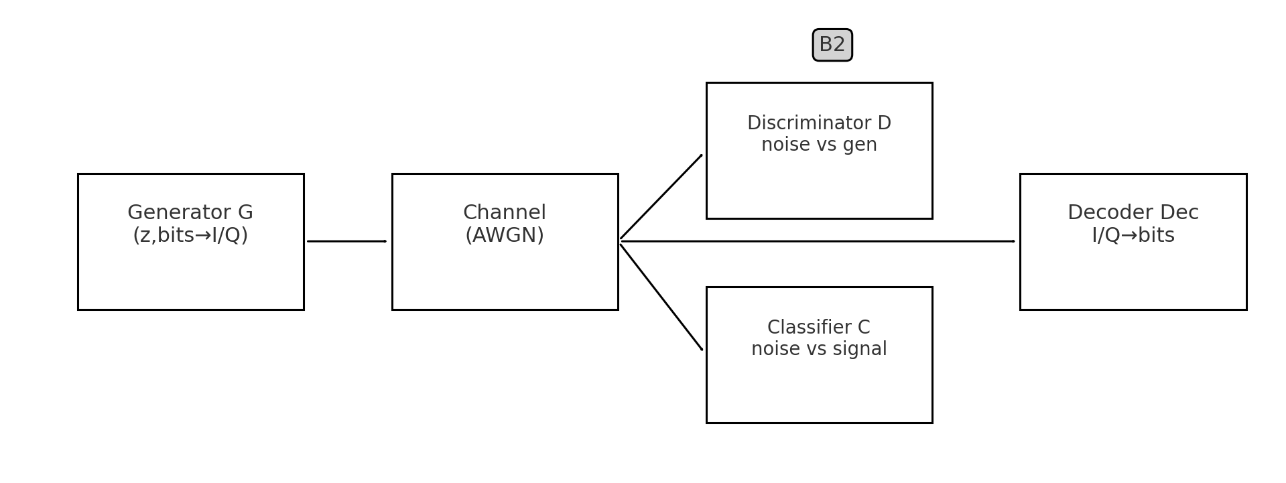
Core modules:
- Generator (MLP): conditional mapping (z, RS bits) → I/Q (tanh).
- Decoder (MLP): I/Q → RS bits (sigmoid); replaces classical demodulator.
- Discriminator (MLP): real-noise vs generated; adversarial critic.
- Signal Classifier (MLP): detector adversary; encourages stealth.
Training objectives:
- Reconstruction (BCE) on bits at Decoder output.
- Adversarial (BCE): G fools D; detection loss (CE): G appears as noise to C.
- Curriculum: start at high SNR; gradually lower SNR; alternate updates.
Next-step improvements: WGAN-GP/hinge loss, gradient penalty, feature matching, spectral (PSD/KL) losses.

8) Security & keying plan (present and deployment-grade)
- Present (lab): XOR mask for demo; single shared key per session.
- Deployment: AES-GCM or ChaCha20-Poly1305; per-frame nonce/IV; MAC for integrity.
- Key management: KDF for session keys; rekey schedule; zeroization; secure storage.
- Optional: cryptographic PRNG to drive frequency hopping/spreading and timing jitter.

9) SDR integration (file formats, flowgraphs, calibration)
- File format: float32 interleaved I/Q (|I|,|Q| ≤ 1).
- Typical lab rates: 1–4 MS/s; calibrate TX gain to meet spectral mask.
- GNU Radio TX: File Source → (Resampler/Throttle) → LPF → Sink (BladeRF/USRP).
- GNU Radio RX: Source → DC Block → AGC → LPF → File Sink → Decoder script.
- Calibration: remove DC; compensate IQ imbalance; capture known test sequences for lab-only checks.

10) Test & validation plan (BER, AUROC, PSD gap; OTA steps)
- Unit tests: bit utilities (pack/unpack), RS encode/decode, XOR mask/unmask.
- Model checks: forward/backward sanity, overfit tiny dataset to verify plumbing.
- Channel sweep: BER & AUROC vs SNR (30→0 dB), CFO, timing offsets; log PSD gap/KL to noise.
- Detectors: radiometer, cyclostationary, baseline CNN—plot Pd vs Pfa and AUROC.
- OTA ladder: coax loopback → shielded near-field → controlled open area; record EVM/BER.

11) Risk register & mitigations
Risk | Impact | Mitigation
GAN instability/mode collapse | Training fails to converge | WGAN-GP/hinge, grad penalty, schedulers
Overfitting to AWGN | Poor OTA performance | Richer impairments; augmentation; curriculum
Detector generalization | Detected in field | Multi-detector training; red-team tests
Key management errors | Compromised confidentiality | AEAD, KDF, rekey, SOPs
SDR impairments | Higher BER/PSD anomalies | Model impairments; calibrate and compensate

12) Roadmap (Phase‑0 → Phase‑3)
- Phase‑0 (Now): AWGN baseline, RS FEC, XOR masking, MLPs; .bin export; basic BER logging.
- Phase‑1: Add WGAN‑GP/hinge, PSD/KL losses; expand channel (Rayleigh, CFO, timing jitter).
- Phase‑2: CNN detectors; AES‑GCM; implicit sync; ablations and full AUROC benchmarking.
- Phase‑3: GNU Radio OTA demos; field SOPs; HIL testing; hardening and report pack.

13) BOM, software stack, field SOPs
Bill of Materials (example lab):
Item | Qty | Notes
BladeRF or USRP B200/B205 | 2 | TX/RX nodes
RF cables/attenuators | Assorted | Loopback, isolation
Laptop/NUC (USB 3.0) | 2 | GNU Radio + Python
(Optional) Spectrum Analyzer | 1 | PSD verification
Software stack:
- Python 3.x; PyTorch; numpy; reedsolo; matplotlib.
- GNU Radio 3.9+ with BladeRF/USRP drivers.
- Config file (YAML/JSON): RS_NSYM, SEQ_LENGTH, LATENT_DIM, SNR, frame size.
Field SOPs (abridged):
- Load keys/config; verify versions.
- Generate frames and .bin; stage in GNU Radio TX.
- Set conservative TX gain; verify spectral mask.
- Start RX capture; monitor BER; rotate session keys.
- Archive logs/configs post-mission.

14) Troubleshooting & FAQ
- High BER → increase RS_NSYM, reduce rate, train at lower SNRs.
- Detector alarms → add PSD/KL loss, train against stronger detectors.
- Clipping → check normalization and TX gain, add limiter.
- CFO drift → implement coarse/fine frequency correction in RX.
- Mismatched parameters → verify frame size, RS settings, and seeds on both ends.

15) Glossary
Term | Meaning
LPI | Low Probability of Intercept
I/Q | In-phase and Quadrature baseband components
AWGN | Additive White Gaussian Noise
RS | Reed–Solomon error-correcting code
AEAD | Authenticated Encryption with Associated Data
AUROC | Area Under ROC (detector performance)
EVM | Error Vector Magnitude (signal quality)

16) Code mapping and parameter appendix
- Preprocessing: xor_mask, rs_encode, rs_decode.
- Models: Generator, Decoder, Discriminator, SignalClassifier classes.
- Channel: add_awgn (extendable to fading/CFO).
- Training: loops optimizing recon+adv+det losses; logging of BER/accuracy.
- Export: encode_and_export_chunk, message_to_chunks for .bin files.
Default parameters (tunable):
Parameter | Default | Notes
RS_NSYM | 16 | More parity → better correction, lower throughput
LATENT_DIM | 16 | Higher → more diversity; tune for stability
SEQ_LENGTH | ≥ 2×RS_TOTAL_BITS | Frames per I/Q sequence
SNR (train) | 20 dB | Use curriculum 25→10 dB
FRAME_CHARS | 4 | Adjust throughput/BER

